The UK Government have now announced dates for the next phases of the ETA rollout for eligible nationals. It is imperative that travellers to the UK are aware that change is imminent.

People travel on short-term trips to the UK for a whole host of reasons: tourism; visiting family and friends; to attend sporting or cultural events; for business trips and study as a visitor. We recognise that the introduction of the Electronic Travel Authorisation (ETA) scheme is a substantive change for millions of travellers, and it is important that this requirement is publicised as widely as possible to ensure that those travelling to the UK can do so as smoothly as possible.

These information events are open to all who are interested in learning about ETA and will be particularly beneficial to those who have no, or limited awareness of the scheme.

Details of ETA events for February and March 2025 are detailed below, they are bookable free of charge on MS Teams Webinar, please register on the link below for your chosen date.

Any questions about the events please contact ETAengagement@homeoffice.gov.uk

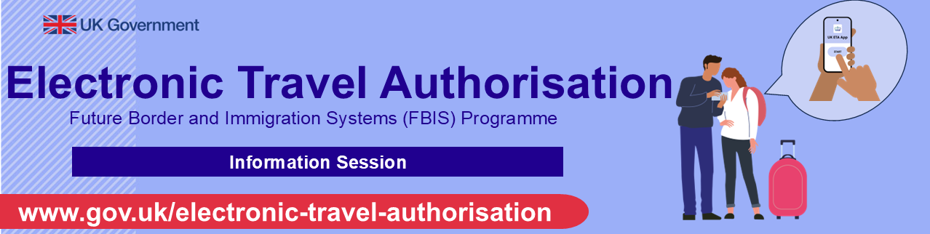

DATE / GMT | MS TEAMS WEBINAR link to register to attend event
Tuesday 18th February 2025  11:00am-12:15pm | Webinar - 18.02.2025 - Register here
Thursday 27th February 2025  14:00pm-15:15pm | Webinar - 27.02.2025 - Register here
Thursday 13th March 2025  07:00am-08:00am | Webinar - 13.03.2025 - Register here
Tuesday 18th March 2025  11:00am-12:15pm | Webinar - 18.03.2025 - Register here
Thursday 27th March 2025  14:00pm-15:15pm | Webinar - 27.03.2025 - Register here

