BMATCH INSTRUCTIONS
- Registration to the event
- Go to the Events Calendar page
- Select the InBuyer event you are interested in and click on the REGISTER button.
- Register by:
  - Using credentials (recommended!)
  - Using your social media account (not recommended!)
Important: The password recovery procedure in the platform is only possible if the company registers by using credentials.
Please note: The first entered email address belongs to the 'owner' of the profile. A second person from the company wishing to participate in the meetings can register and will be associated with the already profiled company.
Please Note: Once you are already registered on the BMATCH platform, you can click on the LOGIN button.

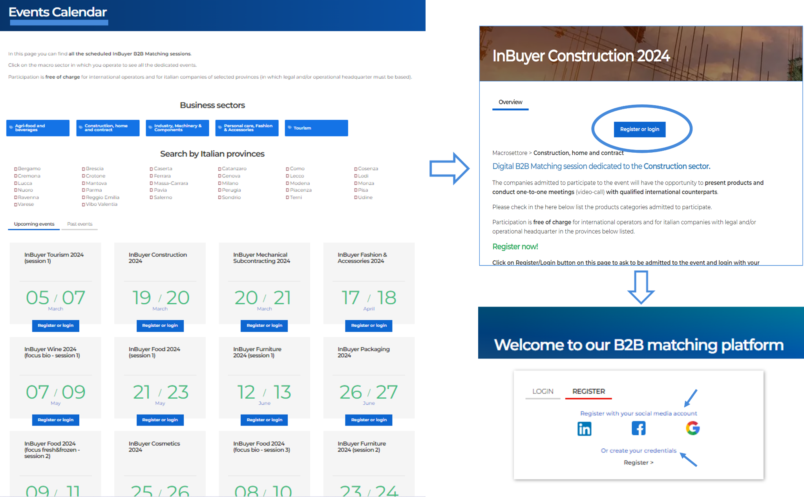

- Creation of the BMATCH profile
Fill in all the required information:

- User Profile → User Profile → User Role, Personal Data (First Name, Last Name, Company, Job Title, Country, City, Phone Number), Corporate Email and Password, Privacy Policy.
Then click on the Proceed button.
- Company Profile → Company Name, Country, Province, City, Address, Zip Code, VAT/Tax ID (not necessary!), Turnover, Number of Employees, Foreign Turnover, Macro-sector, Website, Corporate Email, Phone Number, Social Media, Company Description, Certifications.
Then click on the Save button.
- Event Information → Certifications, Macro-sector, Target, Main Activities you are interested in.
Then click on the Ok button.
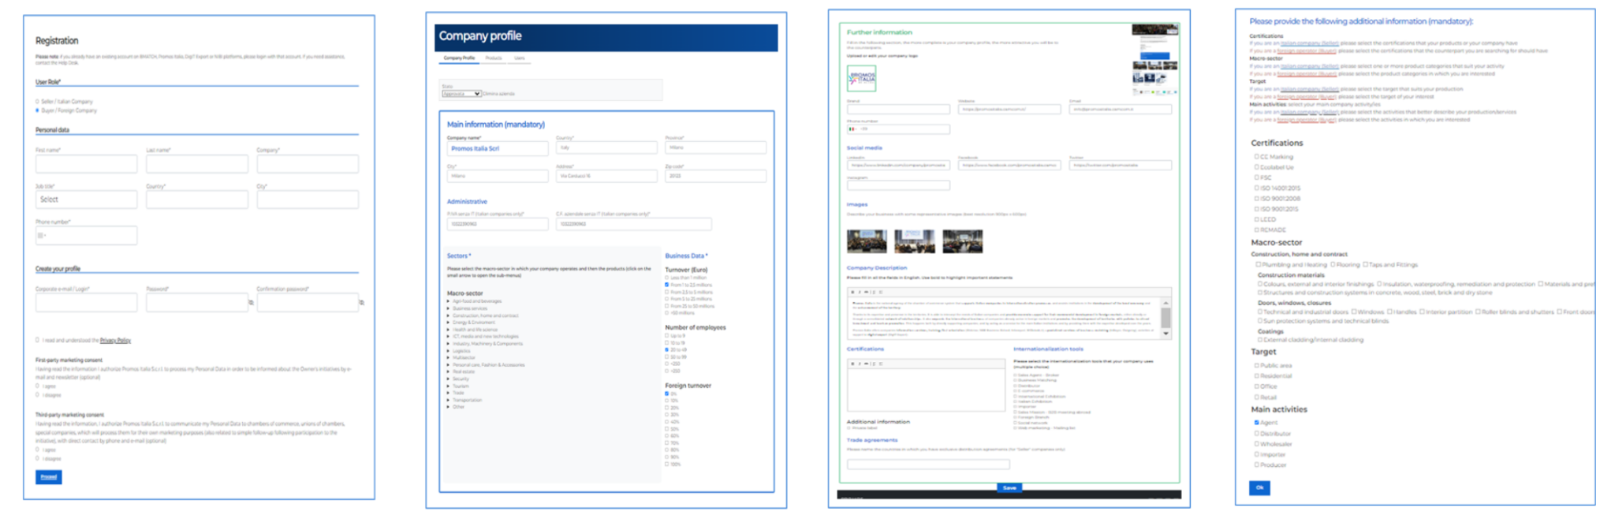
Ensure that all information is provided, as it is functional for the matching process with Italian companies.

After submitting all the required Information:
- Your application will be evaluated by the InBuyer team and approved or rejected;
- you’ll receive updates through email notifications.
Once your registration is approved:
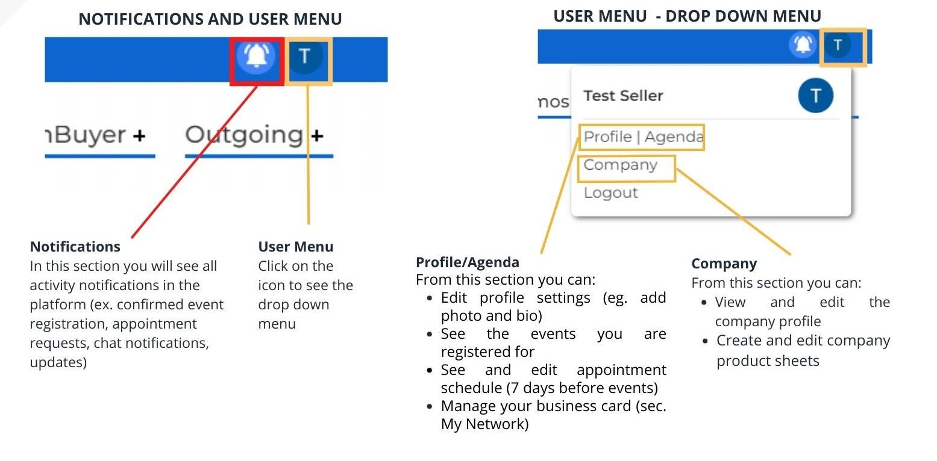
- You will see the navigation bar on the top right corner of your BMATCH profile.

- B2B Matching
7 days before the event you will be able to:
- See your profile agenda and set available/unavailable time slots, using the ‘+’ and ‘-’ symbols
- Accept/reject received appointment requests visible on your agenda
- Search for the Italian companies by clicking on the ‘My Events’ area and entering the ‘B2B Matching’ section
- Click on the name of the contact person you want to meet and send an appointment request
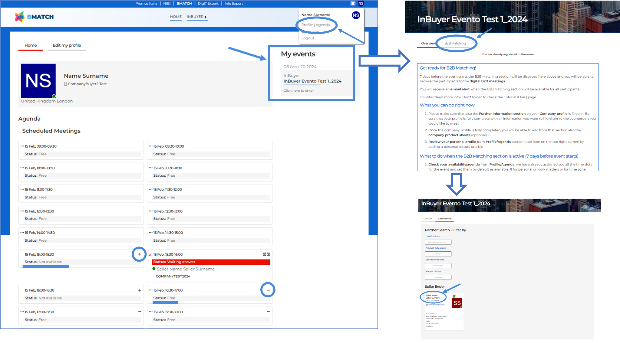
- ON EVENT DAYS
- Access the virtual room of your call directly from your Profile/Agenda, by clicking on the Video Chat button (a small camera) on the slots of each confirmed appointment.
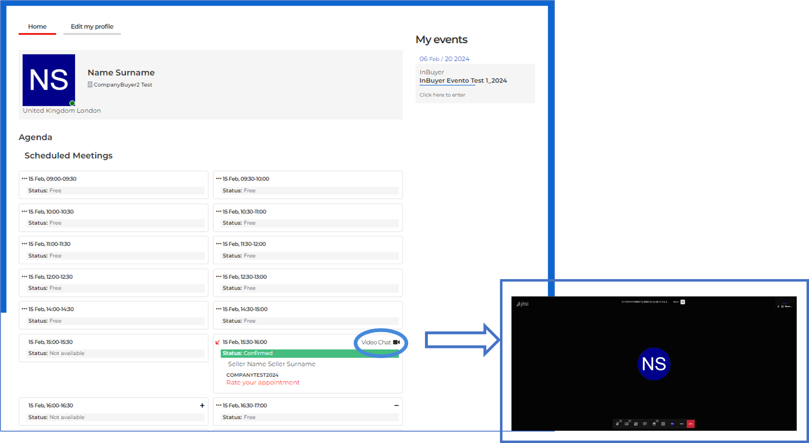
Please note: You will see your appointments according to your time zone, as they will be automatically adjusted to the IP address of the buyer’s personal device.

