S


Who’s attending?

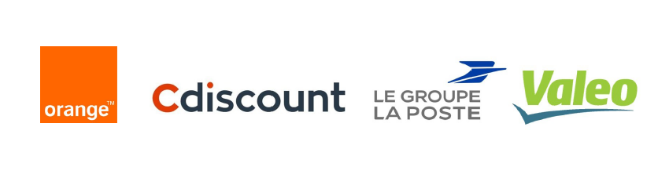

And more coming soon…

What kind of solutions they are looking for?
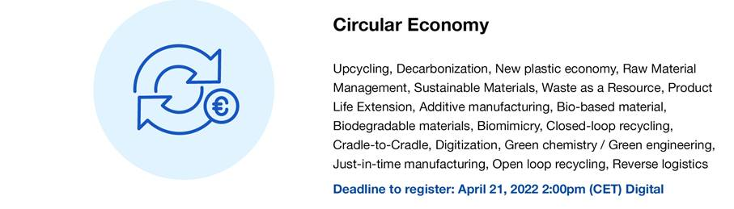

What we offer?
A unique opportunity to connect your company to different large corporations dedicated to the theme and benefit from high-level connections
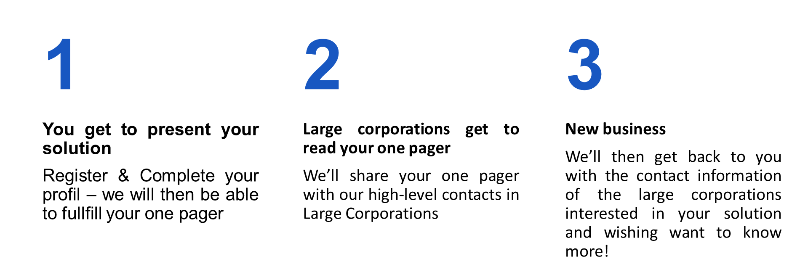

“The Choose Paris Region team will support you before, during and after the TechMeeting to ensure a successful networking experience!”


Deadline for applications: April 21, 2022 2:00pm (CET) - Number of places limited to 40
More information here



